**Water bath test**

Performed by Tomasz Prabucki on 21.06.2018

**Goal:**

To measure the accuracy of thermocouple, SH25 sensor and iButtons using the water bath.

**Equipment:**

* Water bath (Grant Y14)
* Arduino GSM MKR1400 + MKR SD Proto shield
* Si7021 temperature and humidity sensor
* Thermocouple
* Maxim iButton®

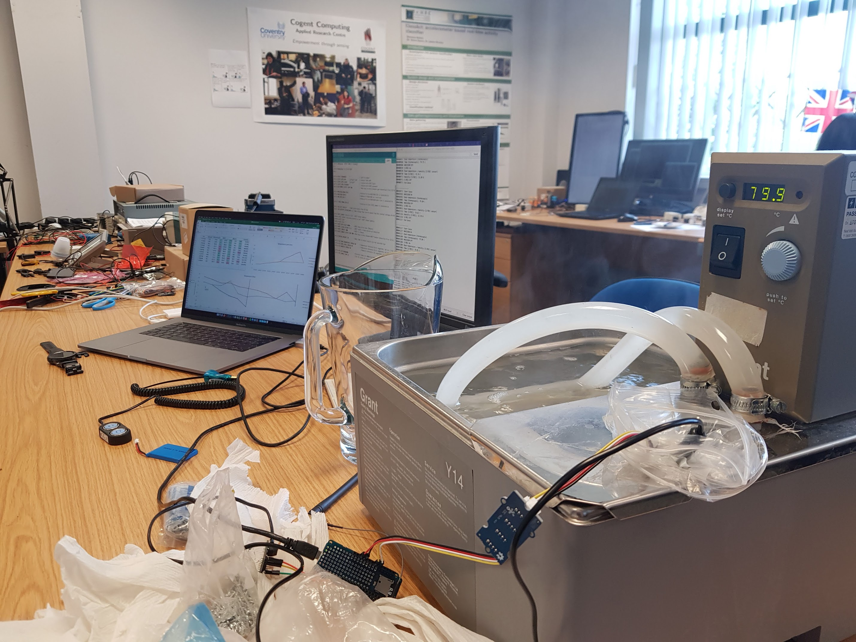

**Preparation:**

* The water bath was filled with cold water
* Arduino sketch was set to read the temperatures every 20 seconds
* The iButton was programmed to read temperatures every 20 seconds
* 2 zip locks, one inside the other, were pushed into water bath, with bag of screws acting as an anchor, to provide a dry environment for thermal sensors to be placed.
* The Arduino was actively connected to computer using USB port, so that the data could be read straight from the serial monitor.
* The water bath temperature was increased from 20C to 80C at 5C intervals.

**Initial failure – test with 1 zip lock:**

The first time the water bath test was conducted, only one zip lock bag was used. However, when the water bath temperature reached 50 degrees, the zip lock broke causing water ingress. This caused the thermocouple to malfunction, showing the temperatures much higher than expected.

The chart above shows that around 12:05, thermocouple started reporting temperatures much higher than what water bath was set to. The rest of the sensors worked correctly.

The second graph shows that, apart from broken thermocouple, the rest of the sensors reported around 0.5 degree offset in relation to actual set temperature.

Since there was a case of water ingress, the experiment was carried out again.

**Second attempt – test with 2 zip locks:**

In this second attempt, the sensors were placed into two zip lock bags.

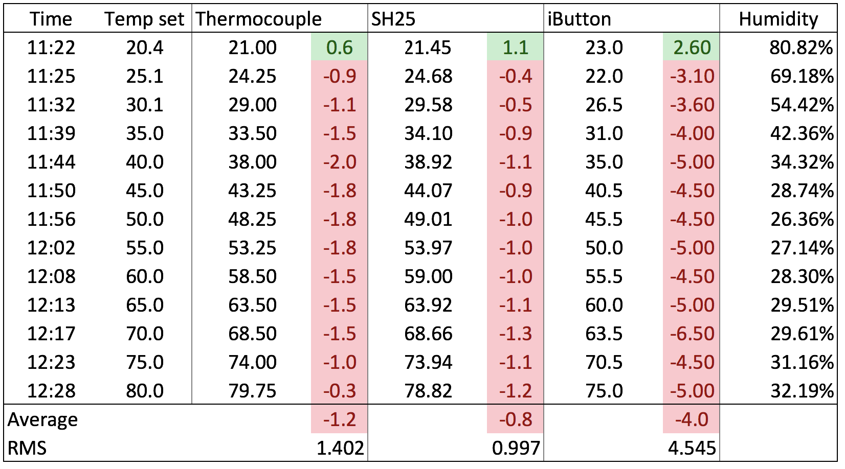

**Observations:**

This time, the test was more consistent, as 2 zip locks survived under the high water temperatures. The test took around 1 hour to complete.

Due to use of 2 zip locks, the temperature offset was increased, compared to the previous test – it now averages at -1.2 degrees for thermocouple, -0.8 for SH25 and -4.0 for iButton. The RMS (Root mean square) equals to around 1.4 degrees for thermocouple and around 1 degree for SH25 sensor, which is suitable to our use case.

The iButton offset has turned out to be much higher compared to other sensors – possibly due to incorrect placement of it in the zip lock. In the first test, the iButton did match the water bath set point.

The offset seems to depend largely on the time difference between setting the water bath temperature and reading the measurement from sensors. For this test, the measurements were taken around 1 minute after setting the water bath temperature. However, the accuracy seemed to increase the longer the wait before reading the temperature – possibly due to zip locks taking their time to heat up along with the water around them.

Regardless of the above, the measured temperatures and their accuracy seem to suffice for our use case.

**Line of best fit calibration equations:**

|  |  |
| --- | --- |
| Thermocouple | y = 0.993x - 0.8705 |
| SH25 sensor | y = 0.9777x + 0.3116 |
| iButton | y = 0.9268x - 0.3823 |

**Other things to note:**

* iButton data was extracted using OneWire Viewer software for Windows.
* Although the iButton was put together with the other sensors in the zip lock, it is fully waterproof, and could be inserted directly in the water for more accurate results.